Welcome to PowerClaim Estimator!

PowerClaim Estimator is a web based program where you can access and manage claims, create new estimates and manage it all in one program wherever you are. From the desktop at the office, your laptop at home or your smartphone on the road.
You can open PowerClaim Estimator by going to your web browser and connecting to http://www.powerclaimestimator.net
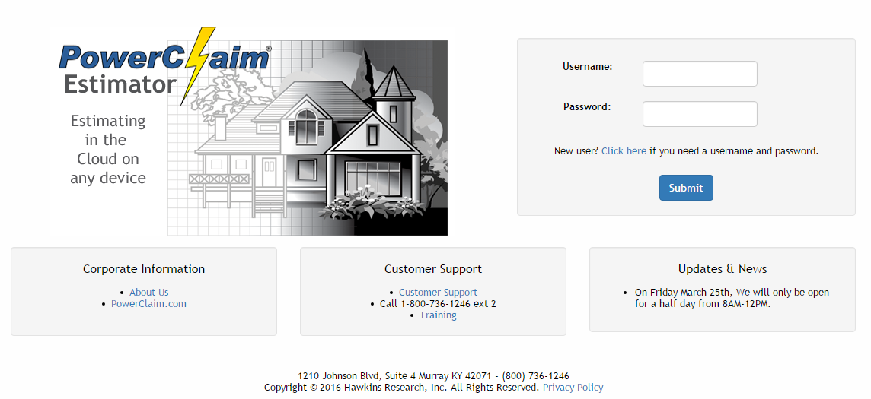
You can log into PowerClaim Estimator by using your login details, provided by Hawkins Research, Inc., or your Manager, in the Username and Password text box to the right and clicking the Submit button.

(All screenshots and layouts in this manual were taken/used in Google Chrome. Powerclaim Estimator is designed to work in all internet browsers, if you have any problems please call our customer support)

Table of Contents
Table of Ccontents 2
How To Make An Estimate 4
Home Screen 9
Tool Bar 10
Recently Active Claims 10
Claim Search 10
Delete Claim 11
Archive Claim 12
Assign Claims 13
Copy Claim 14
Import Claim 15
Contacts 17
New Contact 17
Settings 18
Claim Preferences 18
Default Estimate Settings 19
Default Tax Options 19
Default Regional Cost Adjustment 19
Default Materials Database 19
Default Overhead & Profit Options 20
Miscellaneous 20
Default Report Settings 20
Manage Custom Items 21
Data Manager 21
Claim Setup 22
Add Contacts 23
Estimates 24
Adding Estimates 25
New Claim 26
Edit Estimate 26
Adding Areas 27
Adding Items 28
Items List 28
Adding an Item 29
Adding Custom Items 30
Managing Custom Items 31
Macros 31
View Report 32
Documents 33
Photo 34
Diary Entries 37
Invoice 38
Reports 41
Admin Tools 42
Manage Company (Manager only) 42
Add Branches (Manager only) 43
Add Company Logo (Manager only) 43
Manage Users (Manager only) 45
Manage User Types (Manager only) 46

How To Make An Estimate
(This is a simple guide to starting a claim in Estimator, it will not include everything you need to know but will show you the basics to get started in making one.)

After you have logged into Estimator, you will come to the home screen, and from there you will click on the New Claim button.

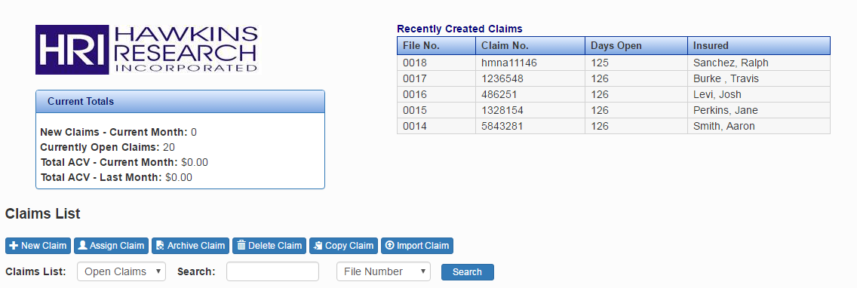

From there you will see the Claim Setup screen, here is where you add your claim info but all that is needed is a file number (that is automatically generated) to go on, once the information has been added click the Save button then click on Estimates to the right of Claim Setup.
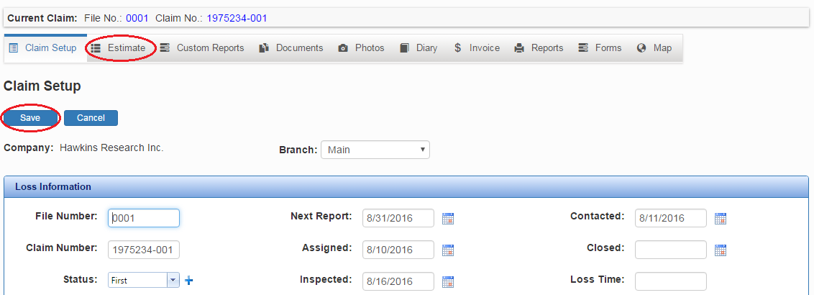

Once you get to the Estimates screen you will see an area of your coverages; to start, click on New Coverage.

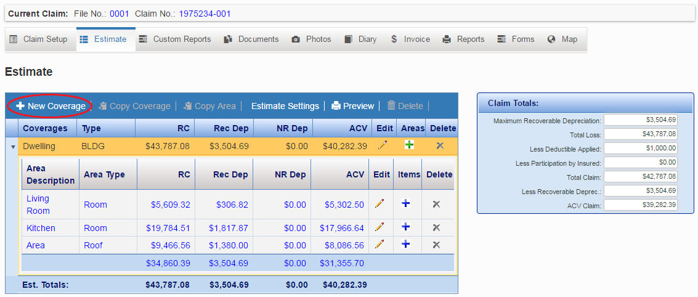

That will take you to the Coverage Setup screen, all you need is the Coverage and Type filled in, there is a drop-down list for both.
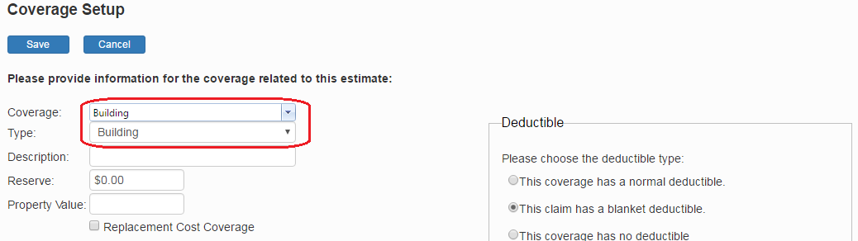

Now in the estimates screen, you will see a new coverage in the list, to add an area go to the right and click on the green plus sign and that will take you to Areas

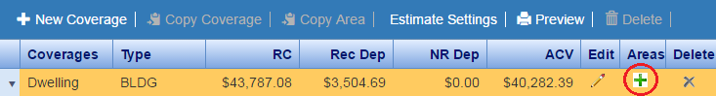

From here you can change/edit the areas size and type, but all you need to add right now is Length, Width, and Height. Then click save.

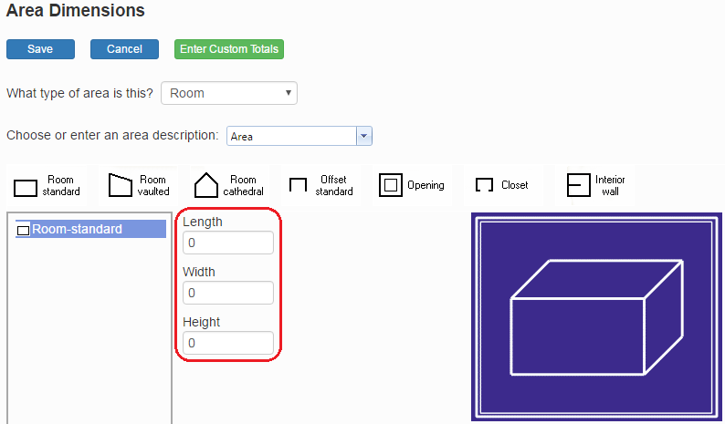

Once you are back at the Estimates screen, you will now see a new area, look to the right in the area line and click on the blue plus sign

Now you are in the items list, look in the top left corner of the items list and click on add item.

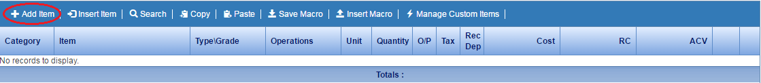

A screen will pop up, and you add the item from there. You need to select your database, category, item, type/grade, quantity, and your operation in the list in the middle. You can change the other options, but that is all you need for an item. Then click save.
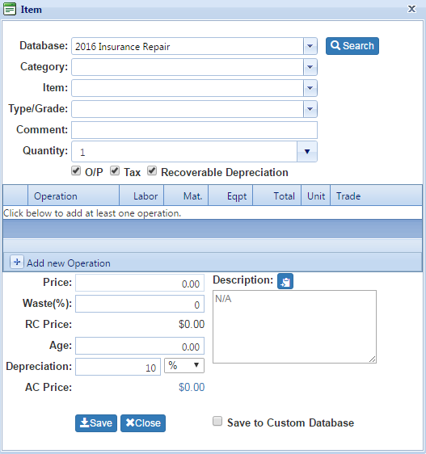

Once you have finished adding your items click on View Report

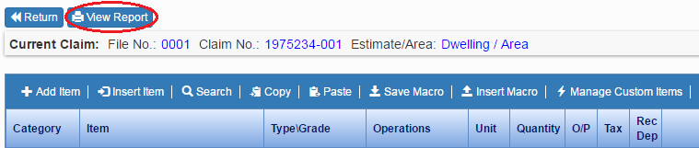

Now you are on the report screen; here you can view the complete estimate, export it to several different file types, save/print your report to your computer. And email your report.
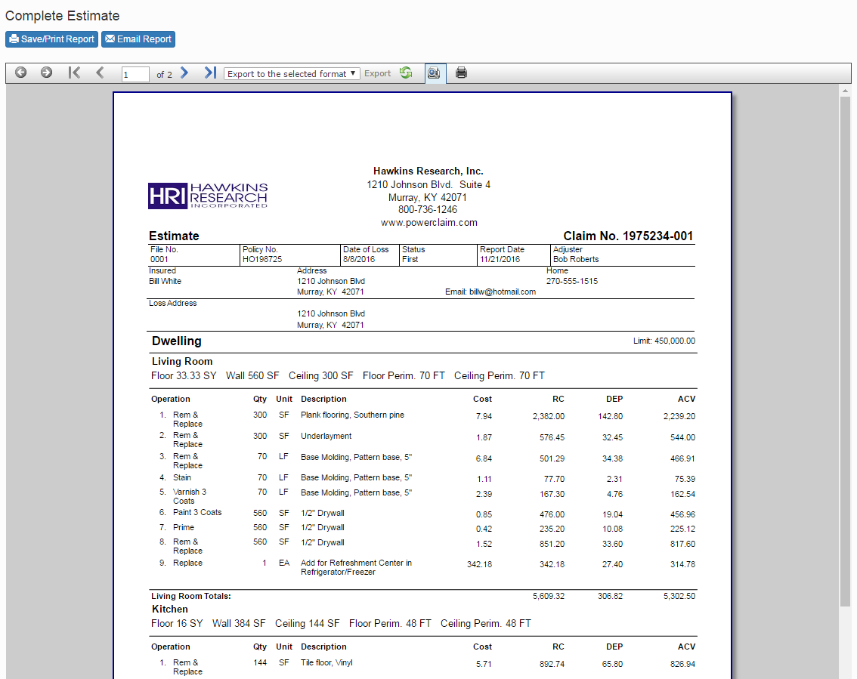

Now you have completed an estimate. This is just simple how-to guide to get you started and show the main steps to get started in Estimator. You can find more information about all that was covered in the rest of the manual.

Home Screen
When you log in you automatically go to the Home Screen, This screen shows:
- Recently Created Claims – At the top right you will see a list of five claims, these are your most recent claims and are sorted by date only.
- Claims List – These are all of your claims, you can click on one to open it and you can sort the whole list by clicking on File No. Claim No. Insured, Adjuster, Days Open, and Status respectively.
- Current Totals – Here you can see how many claims were created in the last month. Your currently open claims, and your ACV for this month and last month.
- Claim Search – Just above the Claims list you will see a search area, you can search by File No. Claim No. Insured, Adjuster, Days Open, and Status. Just chose what you want to search by and fill out the search info (File no. 1357 for example) then click the blue Search button. All the claims that match will show up in the claims list. Click clear to go back to the main claims list.

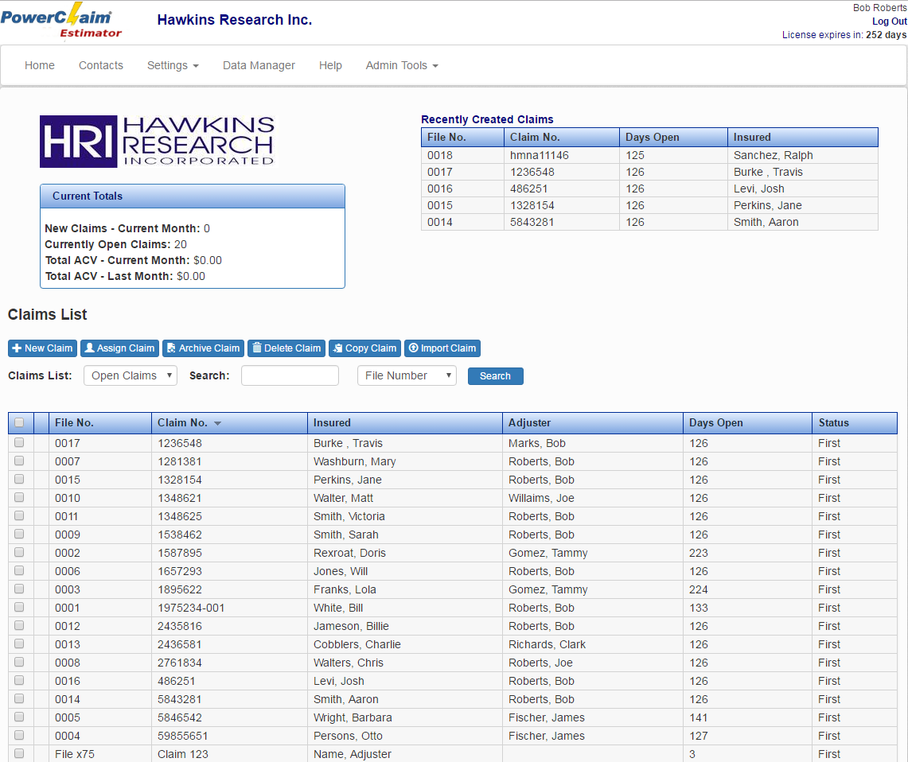

Tool Bar

If you are logged in as a manager: To the top you will find six options. Home, Contacts, Settings, Data Manger, Help, and Admin tools.

If you are logged in as a user: To the top, you will find five options. Home, Contacts, Settings, Data Manger and Help.

- Home- Used to show current activity with your company or to a user the current claim activity.

- Contacts-This gives you a view of your contacts. From this screen, you can add new contacts and us them in Claim Setup.

- Settings - In settings you can access Claim Preferences, Default Estimate Settings, Default Report Settings, and Manage Custom Items.

- Data Manager - Used to add or edit Activity Types, Diary Types, Loss Causes, Status Types, and Policy Types.

- Help – This will take you to this manual.

- Admin Tools - This includes the Manage Users and Company Info Screens. Used to manage users and add company information and logo

Recently Active Claims
This shows you the most recently created claims. From this screen, you can click on a claim, and it will take you to the claim.

Claim Search
Using the Search box, you can search claims by several different parameters: File Number, Claim Number, Insured, Adjuster or Status. The claims that match the information in the Search box will be displayed on the Home screen. You can now edit, delete, archive or assign the claim.

Delete Claim
This option is used to delete a claim from the PowerClaim Estimator server. If you delete a claim, it will no longer show in the reports

To Delete a claim:
▪ Select the claim you would like to Delete.
▪ Click the Delete Claim button.
▪ A popup message will appear "Are you sure you wish to delete this claim?" Click OK or
Cancel.

     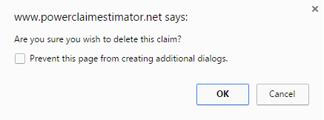

▪ Warning! If you check the box for "Prevent this page from creating additional dialogs.". You won't be able to Archive or Delete claims until you re-enable pop-ups and notifications.

Archive Claim
Archiving a claim will remove them from the claim list and will no longer allow the user to access the selected claim. The claim will still be available for reporting purposes. To get the claim to show in the claim list once it has been archived, please contact Hawkins Research, Inc.

To archive a claim:

- Select the claim you would like to Archive.
- Click the Archive Claim button.
- A popup message will appear "Are you sure you wish to archive this claim?" Click
OK or Cancel.

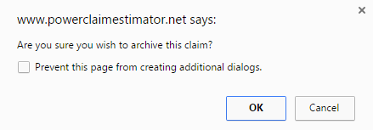

- Warning! If you check the box for "Prevent this page from creating additional dialogs.".
You won't be able to get the popup for Archive or Delete claims until you re-enable pop-ups and notifications.

Assign Claims
Managers and users who have been authorized can assign claims. When a claim is assigned to a user and the assignment is saved, you have the option to send an email notification to the user. Ensure that a valid email address is located in the Account Admin screen for the user and the person assigning the claims.

When the user logs into the system, the assignment details are found on the server. Based on these, the user can start working on the claims.

To assign a claim:
- From the Claim setup screen, click on the claim you want to assign.
- Click the Assign Claim button near the bottom of the page.
- The Assign Claim screen below appears.

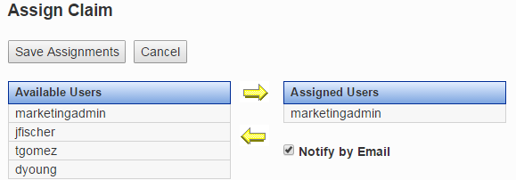
- Click on the user that is to be assigned the claim.
- Click the arrow to move the person to the Assigned Users column.
- Click Save Assignments
To un-assign a claim:
- Click on the user in Assigned Users.
- Click on the arrow pointed left.
- Click Save Assignments.

Copy Claim
To copy a claim check the box for the claim you want to copy in the claims list page and click the Copy Claim button and you will get a popup for what you want to copy from the claim.

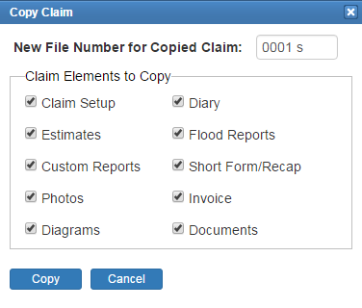
Just select what you want to copy and add a new name or keep the given one then click Copy and it will show up on your claims list.

Import Claim

With the Import Claim feature, you can import claims from PowerClaim XML to Estimator easily, to start you need to save your claim in XML. To do that open up XML and go to the Claims screen, select the claim you want by clicking on it once, and then click on the Save to File button in the bottom left corner.

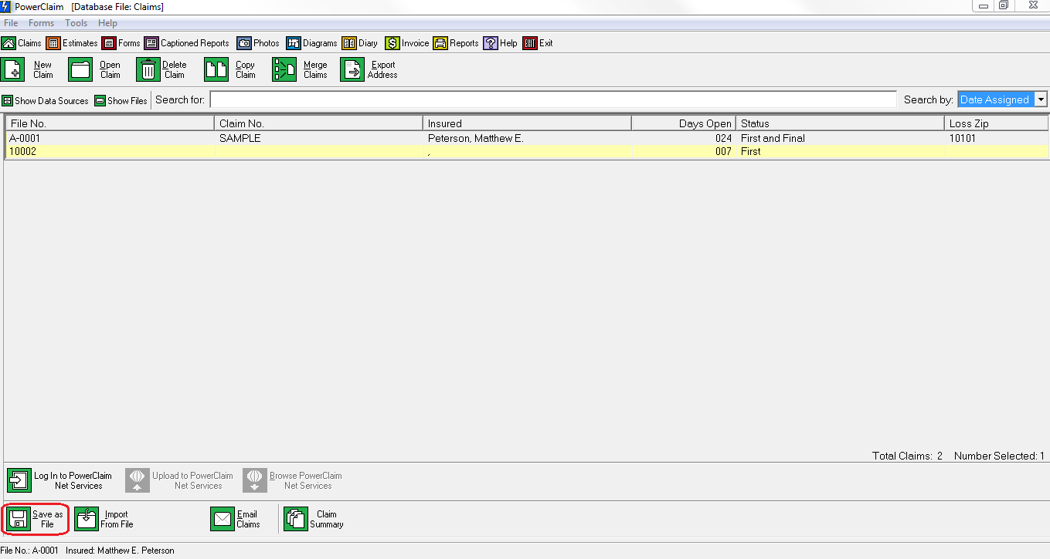

Once you do that, a screen will pop up asking you where you want to save it, what you want to name it and the file type. It does not matter where you save it as long as you can find it again. Name it the file number and make sure it is saved as XML.

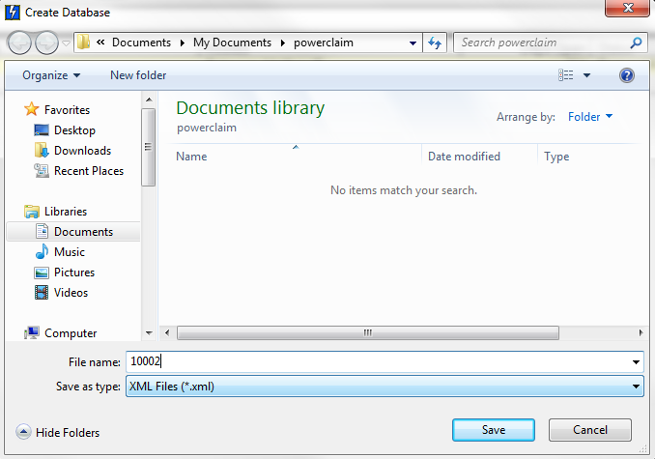

After you have saved the claim, go back to Estimator and click on the Import Claim button right above the search bar. Then this screen will pop up.

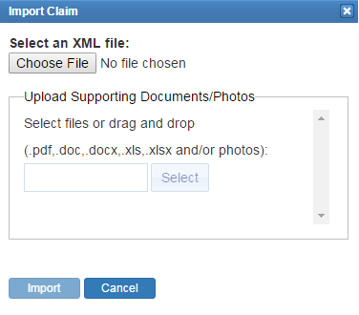

Click on Chose File and then select your saved file, you can also add Supporting Documents/Photos as long as it’s one of the supported file types listed in the window. When you are done click Import at the bottom left corner and it will now be in your claims list.

Contacts
Use the Address Book feature when you wish to save and retrieve contact information. You can get directly to the address book by clicking on Contacts.
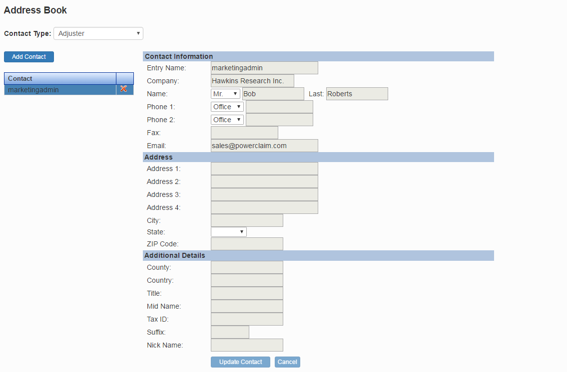

New Contact
- Double-click the contact type you would like to enter and enter the contact information.
- Click Save to Address Book.
- Click Load to Claim to add this contact to the claim you are currently completing.

Load existing contact
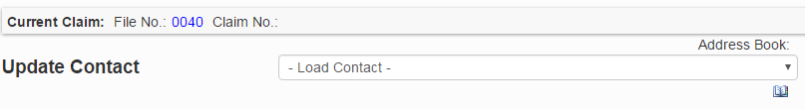
- Click on the contact type.
- Click on the drop-down box Address Book and Load Contact.
- Click on the contact you want to add.
- After the contact information populates, Click Save Contact.

Settings

Claim Preferences
In claim preferences, you can set up “autofill” for user specific claims for their contacts and set up the file number generation settings at the bottom as well. (Example, you can set it so that your adjuster automatically fills in as “Bob Jones” as long as he is in your contacts.)

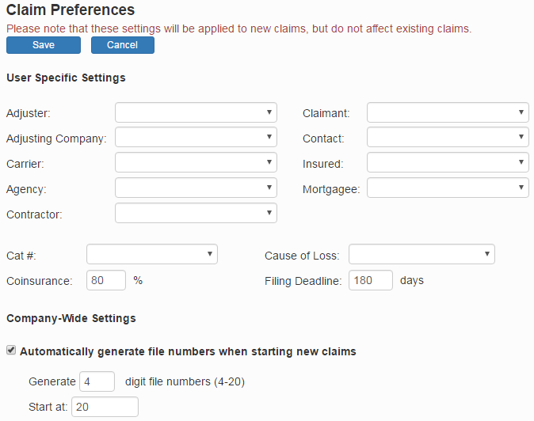

Default Estimate Settings
Here you can set the default setting for all of your future claims; this does NOT affect pre-existing claims.

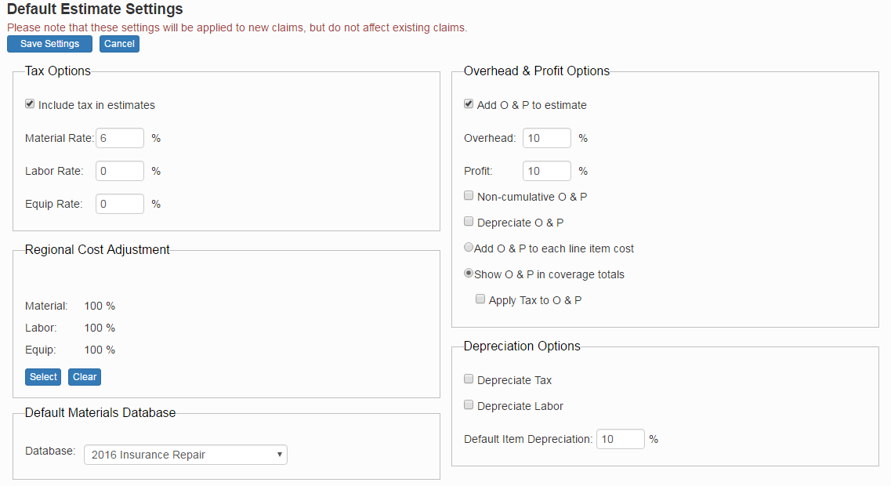

Default Tax Options
Place a check in the "Include tax in estimates" check box to have tax automatically calculated.
Set Material, Labor, and Equipment tax rates in the fields provided.

Default Regional Cost Adjustment
The "Regional Cost Adjustment" affects how database items are adjusted to meet the local cost index. Choose the region that is closest to the area of work by clicking the Select button.
Clicking Clear will return the settings back to the national average.

Default Materials Database

Here you can change the Default database for creating new claims.

Default Overhead & Profit Options
Place a check in the "Add O & P to estimate" checkbox to automatically add overhead and profit to the estimate items.
Set "Overhead" and "Profit" rates in the field provided.
To calculate overhead and profit separately, place a check in the "Non-cumulative O & P" check box. To calculate overhead and then calculate the profit based on the sum of the cost plus the overhead, clear this check box.
Check the "Depreciate O & P" box to include O & P when calculating depreciation.

Miscellaneous
Tax and Labor can be optionally depreciated. Choose the appropriate settings for the defaults.
The "Item Depreciation" field will set a default depreciation percentage for all new line items.

Default Report Settings

In Default Report Settings you can edit your General Settings, Default Header, Default Cover Sheet Comments, Default Estimate Disclaimer, and Default Additional Payment Agreement (For Alternate R/C Statement). You can also change your company logo here as well.

- General settings – you can choose a few things to add or remove from your report.
- Default header – you have five lines to add to your header, it will autofill to your contact information.
- Default Cover Sheet Comments – Comments that will automatically fill your report cover sheet.
- Default Estimate Disclaimer – you can add multiple templates for your disclaimer, to add a new one click on Add New Disclaimer, fill in the name and type it out in the box below and click save.
- Default Additional Payment Agreement (For Alternate R/C Statement). – You can edit/add to your agreement here that will show up in your report.

Manage Custom Items

To manage your custom items click on Settings at the top of the page and click on Manage Custom Items from the drop-down.

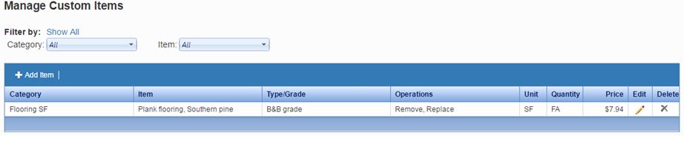
From here you can see all of your custom items, and you can edit, sort, and delete from here so you can access them from any claim you are working on.

Data Manager
Here you can access and edit all of your data, to the left you have your fields of data and to the right you have your data items. To add a new data item click on New Entry, fill out the boxes and click save. To edit a data item just double click it.

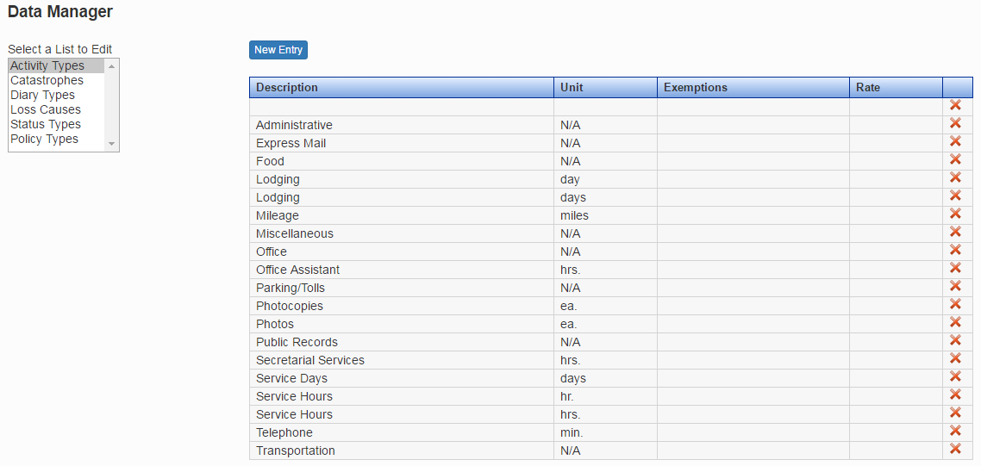

Claim Setup
To start a claim file on the Manage Claims screen click the New Claim button. The New Claim screen is where much of the general information about a claim will be entered. There are three main sections: Loss Information, Policy, and Contact Information. Enter the Loss Information, Policy and Contacts and click the Save button.

The File Number and Claim Number are required to save the claim. The Contact Information section is used to record information about all of the participants in the claim. You must have the File Number and Claim Number to enter contact information.

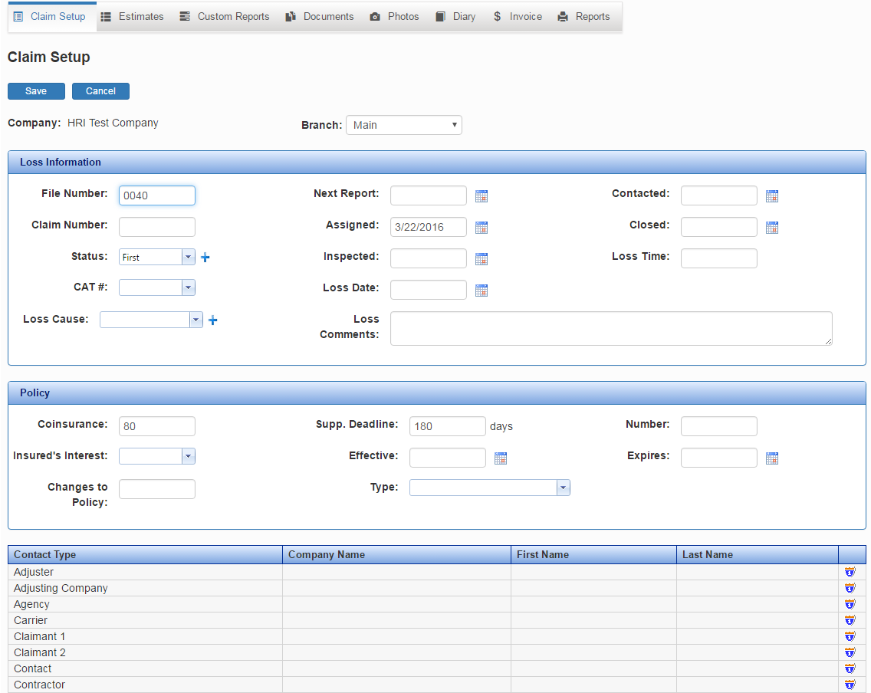

Add Contacts
- Double click on the Contact Type you want to enter.
- The Update Contact screen will appear.
- Enter your contact information, and click Save Contact. You can also save to the Address Book to use in future claims by clicking Save to Address Book.
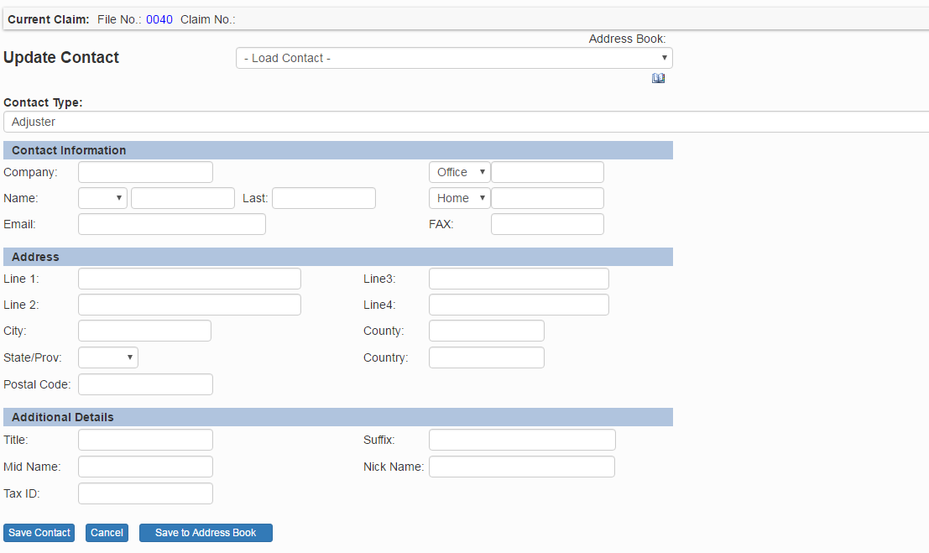

Estimates
After you open a new claim and finish the claim set up, you can start on the estimates.

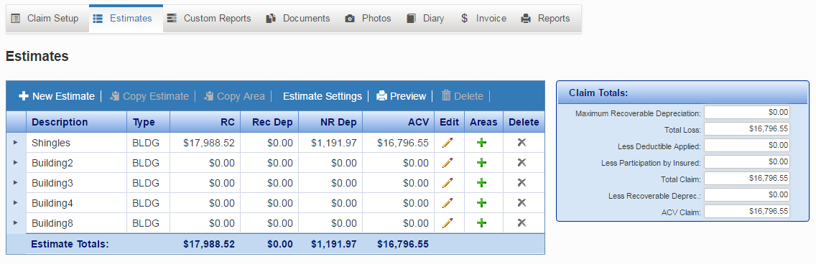

To the right of the areas and items list, you will see a claims total list with information about the entire claim. You can see Maximum Recoverable Depreciation, Total Loss, Less Deductible Applied, Less Participation by Insured, Total Claim, Less Recoverable Deprec, and ACV Claim.

On the right side of the estimates entries, you will see three buttons. A pencil, where you can change the estimate setup. A green plus sign, where you can add an area. And a gray “X” which will delete the estimate.

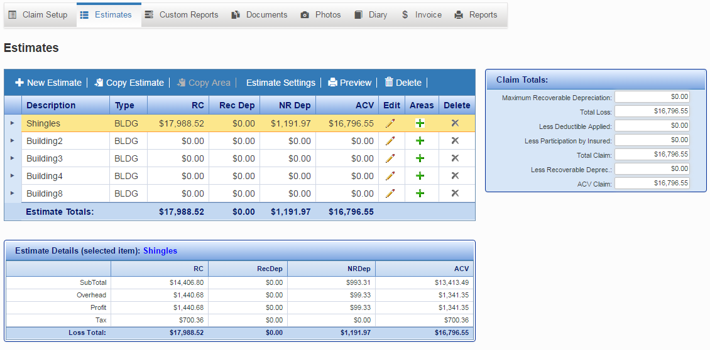

When you click on an estimate, the estimate details will pop up on the Coverage Details screen below the list.

Adding Estimates

To add a new estimate click on the New Coverage button, this will take you to the Coverage Setup screen. You can go back and change this information later by clicking on the pencil under Edit.

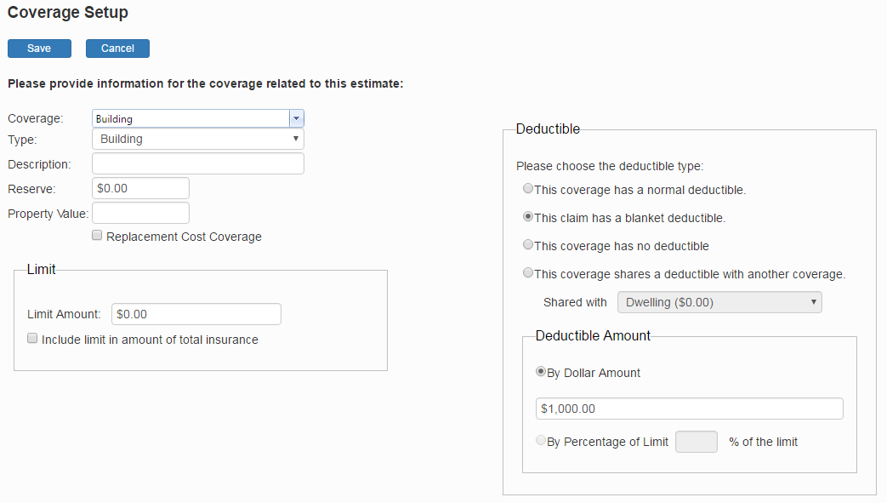
From here you can change the Coverage, Type, Description, Reserve, Limit, Deductible, and Deductible Amount.

To get to the individual areas to edit/change the items, click on the small drop-down triangle to the left of the estimate you want to edit to see the list.
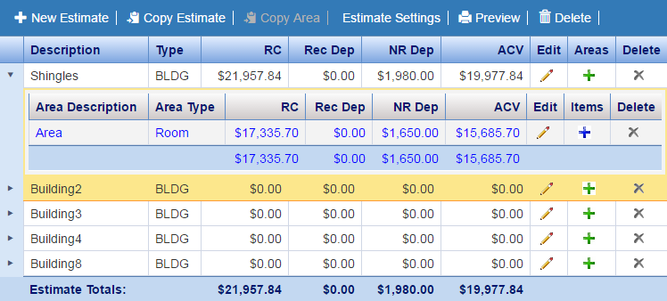From here you can add items and edit area dimensions, to edit the area click on the pencil, and click on the blue plus sign to add items to the area.

New Claim
To start a claim file on the Manage Claims screen click the New Claim button. The Claim Setup screen is where much of the general information about a claim will be entered.

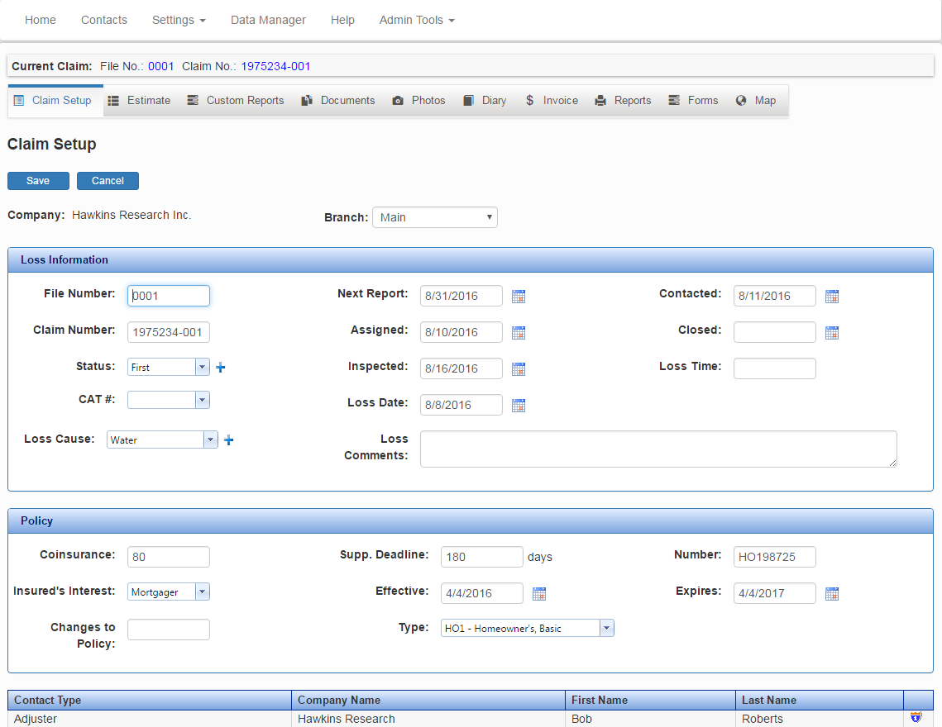

Edit Estimate

When you click on the Pencil in the Edit column, you will go to that estimates setup page.

Adding Areas

When you first add an area, you will go to the Area Dimensions screen.

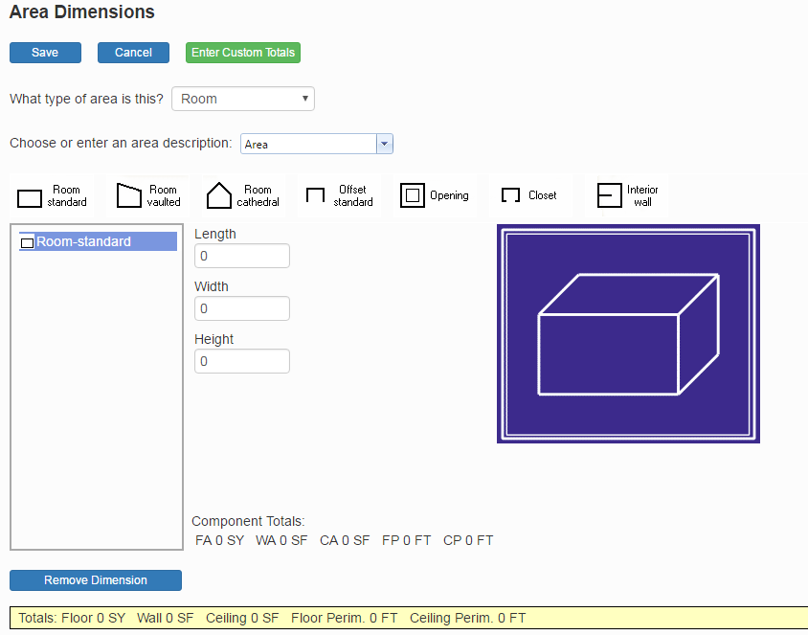

Here you can change area description, the type of area, the style, and the room dimensions. You can add multiple areas in the list to the left of the screen. At the bottom of the screen, you will see the totals of the dimensions of the area you are working in.

At the top, you have Save, Cancel, and Enter Custom Totals.
- Save – Save your area.
- Cancel – Click on this button to cancel the whole area.
- Enter Custom Totals – Clink on this button to add a custom dimension, select the type of area and fill in the boxes below with your information and click save.

In the Dimensions box to the left, you can see all of the dimensions you have added and remove them with the button below the box that says Remove Dimensions.

For types of areas, you have Room, Roof, Exterior, and No Demissions.

Room – you have the options to choose the style of room from the available options listed above the Dimensions box: Room standard, Room Vaulted, Room Cathedral, Offset Standard, Opening, Closet, and Interior Wall.

Roof – you have the options to choose the style of roof from the available options listed above the Dimensions box: Rectangular slope. Triangular Slope, Trapezoidal Slope and Parallelogram Slope.

Exterior – You have the options to choose the style of exterior from the available options listed above the Dimensions box: Exterior Wall, Gable Selection, and Wall Opening.

No Dimensions – you cannot add any dimensions here, this is for if you don’t have/want dimensions in this area.

Adding Items

When you have made an area, you will see that area in a list below the estimate you made it under

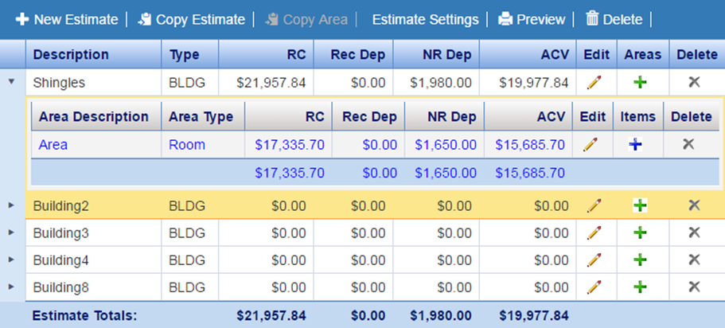

To add items, click on the blue plus sign to the right. That will talk you to the items list, from here you can add, edit, and delete items in that area.

Items List

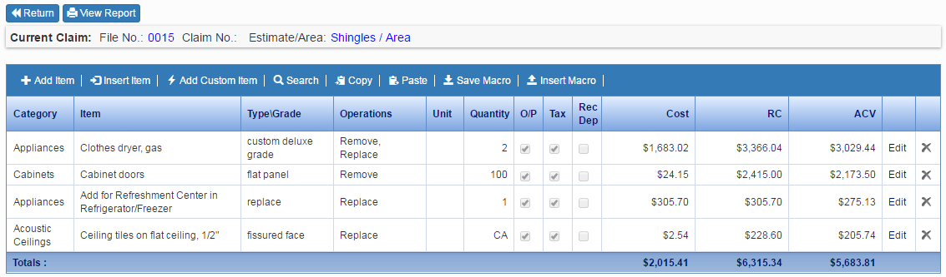

Above the items list, you will see two buttons, Return, and view Report.

- Return – This will take you back to the area list,
- View Report – This will generate a report for the area you are in.

You will also see eight buttons at the top of the of the list; Add Item, Inset item, Add Custom Item, Search, Copy, Paste, Save Macro, and Insert Macro.

- Add Item - Click to add a Pre-existing item from our database.
- Inset item - Works the same as Add Item, but will insert the item into the list right above the currently highlighted item.
- Search – from here you can find an item by searching our databases.
- Copy – copy’s a selected item.
- Paste – paste’s your selected item into your item list
- Save Macro – With this tool, you have an item selected you can click on this tool and save it under a macro under a custom name.
- Insert Macro - Inserts a selected macro from your macro list to be inserted into the items list.
- Manage Custom Items – from here you can Manage all of your custom items in a list for quick access

To the right side of the list, you will see Edit and a gray “X.” Edit will allow you to change the selected estimate as if you were making a new one. The “X” will delete the item from the list. And at the bottom, you see your estimate totals.

Adding an Item
When you click the Add item or Insert Item* button, this screen will pop up.
- Database – Chose which Database you get the item estimate from. There is a search button to the right as well.
- Category – Chose the category to get the item list for said category.
- Item – Lets you chose the item from the category list.
- Type/Grade – Gives more detail for the item you just chose.
- Comment – Area for any comments for the item
- Quantity – Sets the quantity of the item.
- Check boxes for adding O/P, Tax, and Recoverable Depreciation
- Operation – lets you decide what you will be doing to the selected item (Clean, Replace, Remove, Etc. you can also add a new operation).
- Price – Shows the base cost before adding Waste, Age, etc.
- Waste – Sets the waste for the item.
- RC Price – the calculated price for the item/operation listed above.
- Age – input for the current age of the item.
- Depreciation – allows you to set the depreciation percentage for the item/operation
- AC Price – The total price for the item and operation.
- Add to Custom Database – Check this box to add it to your custom items list
At the bottom of the window, there are two buttons, OK and Cancel. Click OK to save the item and Cancel to erase it.

Adding Custom Items

To add a custom item from an estimate item click on Add Item and at the bottom of the popup box check Save to Custom Database and add the info then click save.

To add your own item from scratch click on Manage custom items from the items list or in the settings dropdown from the top of the page. Once you do that click on Add item at the top left corner of the list, and you get a popup window where you can add any item you need.

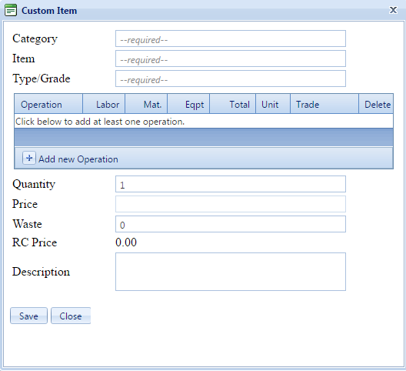

Once you fill out the required information and anything else you want to add click on save and it will now be in your custom items list.

Managing Custom Items
To manage your custom items click on Settings at the top of the page and click on Manage Custom Items from the drop-down.

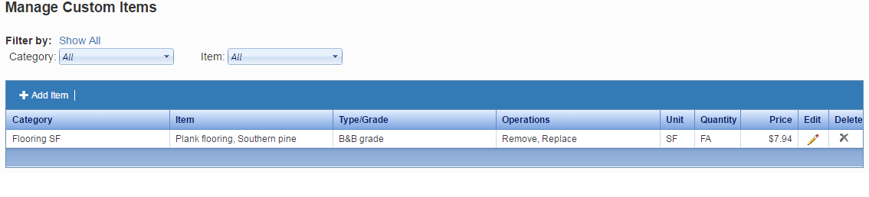
From here you can see all of your custom items, and you can edit, sort, and delete them from here as well. You can access them from any claim you are working in.

Macros

Macros will allow you to save a certain item for future use. To save a Macro select an item you have on your list then click on the Save Macro button, you will see this screen pop up.

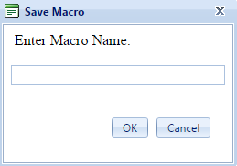

From here you will add a name for the macro for future reference, then click OK to save it.

Then to add a saved Macro click on the Insert Macro button and you will see this popup.
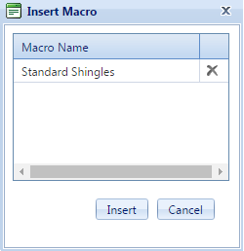
Here, click on the macro you wish to use and click on insert, and it will be added to the item list.

View Report

To view the report for the area click on View Report and it will take you to the Report viewer, this will show you the full report for the Claim.

From here you can view the Report, Save/Print, Email, Export it, and Print it.

Documents
This lets you attach documents to the claim file.
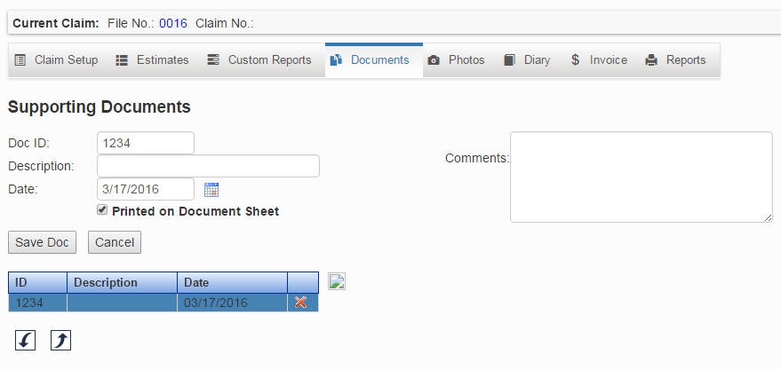
Adding a Document
This lets you attach PDF, gif, jpg, jpeg, and png documents to the claim file.

- Click the Add Doc button.
- Enter Doc ID, Description, Date, and Comments.
- Click the Browse button to locate the file you would like to attach to the file.
- Click the Save Doc button. The document will now appear in the list.

Export a document
To view PDF documents, click the Export button. Some graphic and picture formats like .gif, .jpg, jpeg, and .png will display at the bottom of the screen. Exporting allows you to save the full resolution images as well.

- Click on the document you want to export.
- Click the Export button.

Delete a document
- Click on the for the document you want to delete.
- A pop-up window will appear "Are you sure you wish to delete this entry?" Click the OK button to delete.

.

Photo

Adding a Photo
This lets you attach photos to the claim file.

To add a photo click the “Add Photo” button

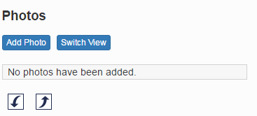

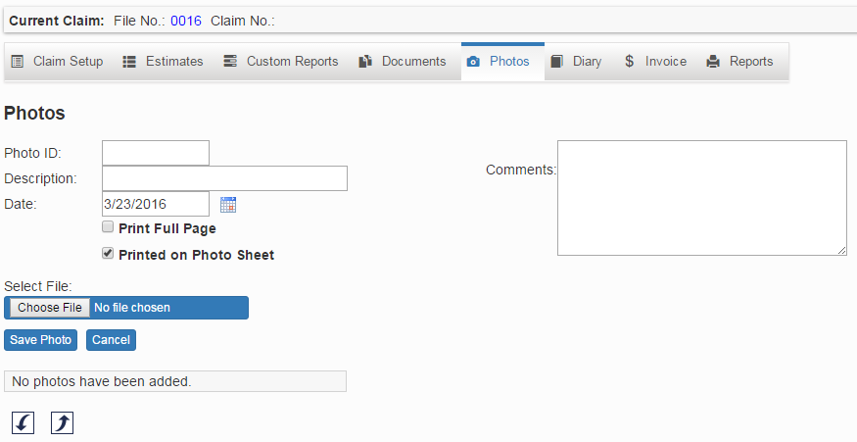

- Enter Photo ID, Description, Date, and Comments.
- Click the Browse button to locate the photo you would like to attach to the file.
- Click the Save Photo button. The document will now appear in the list.

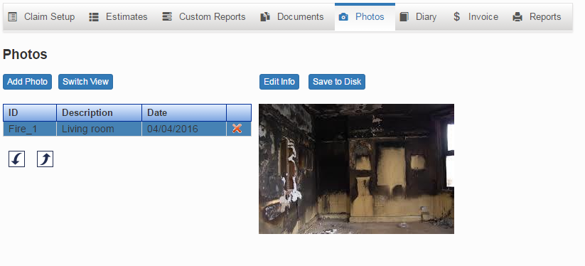

Export a photo
To view photos, click the Export button. Some graphic and picture formats like .gif, .jpg, jpeg, and .png will display on the screen. Exporting allows you to save the full resolution images as well.

▪ Click on the document you want to export.
▪ Click the Export button.

Delete a photo
▪ Click on the by the photo you want to delete.
▪ A pop-up window will appear "Are you sure you wish to delete this entry?" Click the OK button to delete.

Diary Entries
The Diary Screen is where you enter and view diary entries. Logged in as a Manager, the diary entries can be displayed by Current Claim, All My Entries and All Entries. Logged in as a User, the diary entries are displayed by Current Claim and All My Entries. To view the complete diary entry click on the entry, and the diary entry will be displayed.
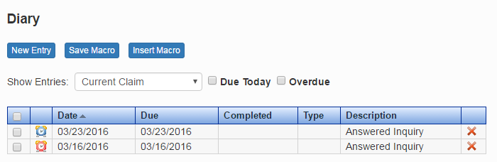

Diary entry is Overdue. Diary entry is Due Today. Delete the Diary entry.
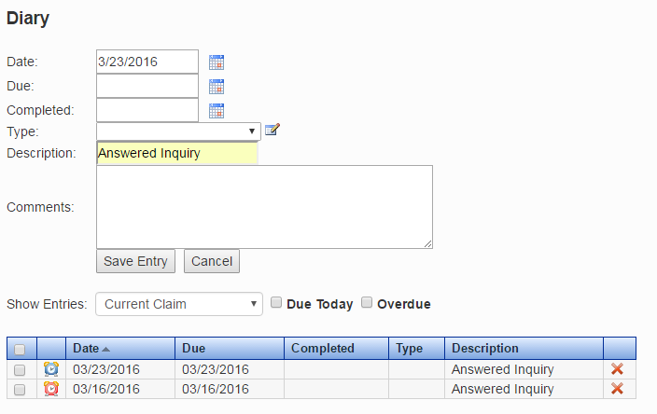
Adding a Diary Entry.
- Click on the New Entry button.
- Enter the information for the diary entry.
- Click the Save Entry button to save the diary entry.
The Data Manager provides the ability to edit items that appear in lists throughout PowerClaim Estimator.

Invoice
The Invoicing section can assist you in determining what is owed for services rendered, as well as for billing adjusting companies and carriers for services. Click New to add an Invoice.
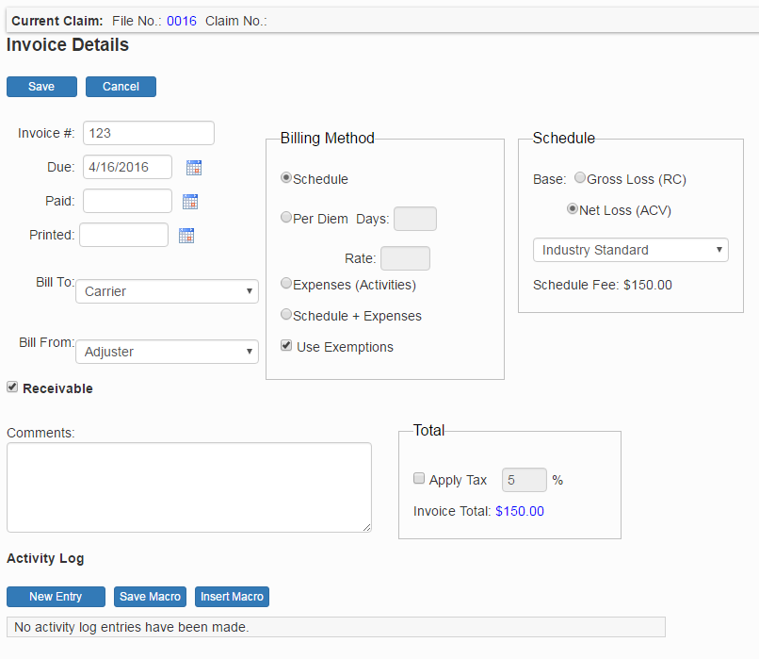

Invoice Details
This section displays the invoice billing options. It enables the adjuster to specify the invoice number and noteworthy dates.
Invoices can be billed to either the carrier or adjusting company from either the adjuster or adjusting company.

Billing Method
This section displays the options for the billing method.

Schedule: This option should be selected if you would like to use a schedule of billing.

Per Diem: Use this option if you would like your billing method to be accumulated per day.
Time & Expenses (Activities): If this option is checked, the invoice will use the entries in the activity log to determine the amount of your time and expense.

Schedule + Time & Expenses: This will combine both the "Schedule" option and the "Time & Expenses" option for your invoice total.

Group Expenses: This option will change your report so that all like expenses will be grouped
into one entry.

Use Exemptions: This option will factor in any exemptions you have specified for each particular type of item.

Schedule
The Schedule calculates the invoice based upon a payment schedule. To switch between schedules, click the down arrow and select your schedule.

Total
This will show you the total of the invoice and also allow you to select your tax options.
To select your tax options fill in the desired tax percentage and check the Apply Tax check box.

Comments
The Comments box can be used to personalize an invoice or add explanatory notes.

Activity Log
To add a new Activity click on the New Entry button.
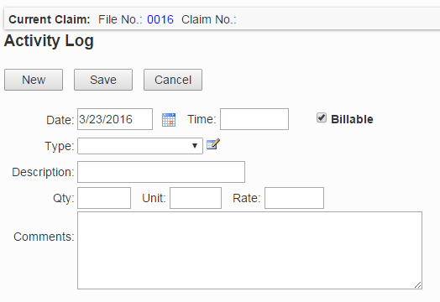
Date: Automatically displays today's date, but can be changed to any date by clicking the calendar icon.

Time: The time the Invoice task was done.

Description: A brief summary of the task. It is listed in the yellow grid on the primary Invoice screen.

Type: The category of the task performed. The types and rates available in this box can be edited by clicking on the button.

Quantity: The number of services provided.

Unit: The unit of the services provided

Comments: A more lengthy description of the task, if needed.

After entering all desired information, click on the New button to immediately begin another entry without having to return to the Invoice screen. If no additional entries are needed, click the Save button or Cancel to cancel your entry.

Reports

In Reports, you can get a better and deeper look at your report, you can decide what you want to show on the report and have quick access to some common settings as well
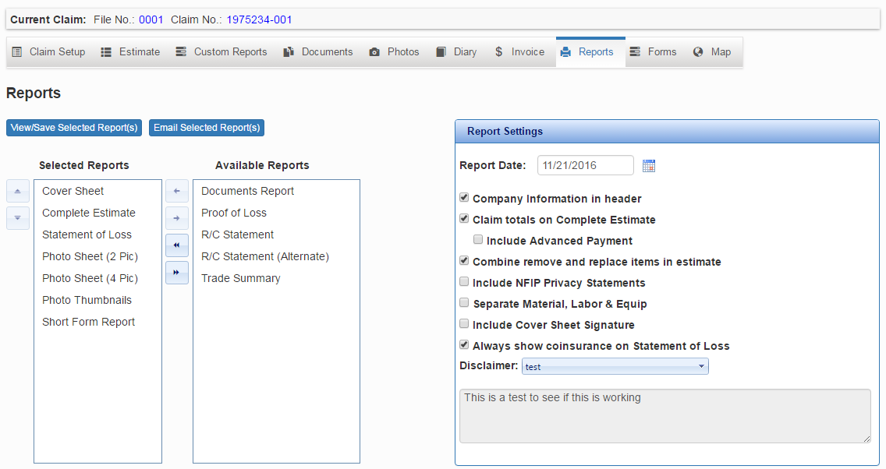

To the right you have the Report settings, from here you can choose some information to include/exclude from the report, For example, Signatures, Disclaimers, and information about the company. You can get into more detail what theses from Default Report Settings in the Settings tab at the top of the page.

And to the left, you have individual reports you can add to the whole report so you can have a short and simple report or a long and inclusive report.

- Cover Sheet – Gives a small amount of information about the claim
- Complete Estimate – Gives a list of the estimate items, areas, and their prices
- Statement of Loss – Gives a short list of the prices from the estimate
- Photo Sheet (2 Pic) – Shows two pictures one on top of the other and the info
- Photo Sheet (4 Pic) – Same as 2 pic but four pictures in a grid
- Photo thumbnails – Shows all the pictures in a 3x3 grid
- Short Form Report – Gives a one-page overview of the claim and contacts
- Documents Report – Shows the Documents you added in the claim
- Proof of Loss – Gives you the Sworn statement for the proof of loss add all the information it and automatically add
- R/C Statement – Gives a statement for the total cost of the estimate
- R/C Statement (Alternate) – Gives an Alternative statement
- Trade Summary – Gives you a “receipt” for the full cost of the estimate

Admin Tools
Each company can be set up with its own account and company logo. Each company consists of a subset called branches. A user will be assigned a specific branch during creation. All users may view Company Information, but only those with roles of Managers and User Managers may edit or view Company Information or add/edit/delete Branch Information. To open the Manage Company screen, click on Manage Company in Admin Tools at the top of the page. Enter the information that you want to change and click Update Company button.
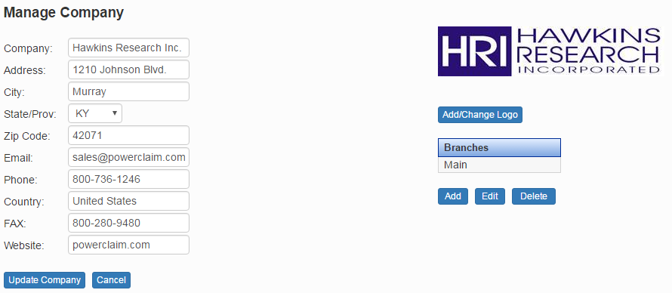

Manage Company (Manager only)

To add and manage your company in PowerClaim Estimator

- Click on Admin Tools
- Click on Manage Company
Enter the information you would like to edit or add to the Company Info and click the Update Company button.

Add Branches (Manager only)

To add a Branch
- Click on Admin tools.
- Click on Manage Company.
- Click the Add button underneath the branches list to the right side of the page.
- Fill out all of the information and click Create Branch to save it.

To Edit Branches
- Select a Branch and click the Edit button.
- Edit the Branch information and click the Update Branch button.

To Delete Branches
- Select a Branch and click the Delete button.
- A message will appear "Are you sure you wish to delete this branch?"
Click the OK button to delete.

Add Company Logo (Manager only)
To add a Company Logo click on the link Add/Change Logo on the Manage Company Screen.
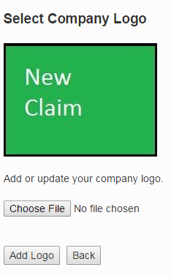
To add the logo click on the Browse button, and locate your company logo on your computer or your company’s network. After you have located your logo, click on the file. It will now appear in the box beside the Browse button. Click Add Logo button. Your company logo will now be shown on the screen.

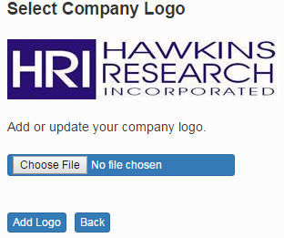

Manage Users (Manager only)

To manage your users in estimator click on Admin Tools at the top of the page and then click on Manage Users
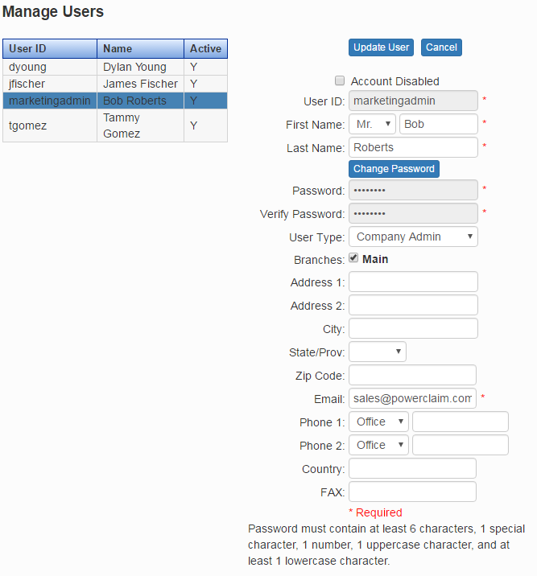

From here you can edit all of the Info for your users, name, address, and contact information. You can also see if they are still active in the list to the left side of the page.

Manage User Types (Manager only)

From here you can decide what each type of user has permission to access/change and to add new types of your own. These can be edited on the fly by anyone with the permission.

